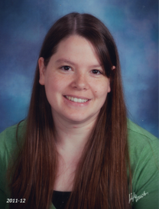****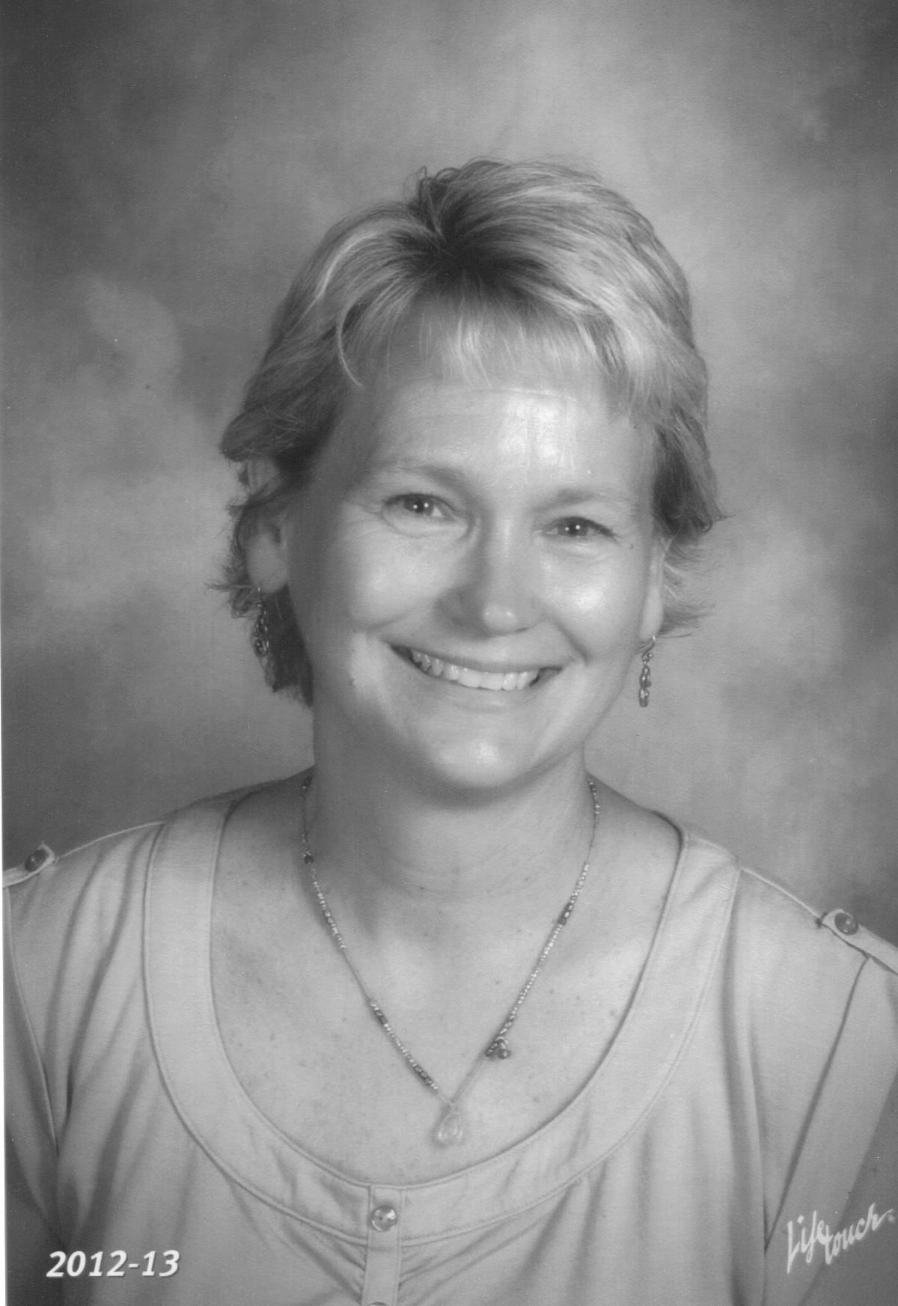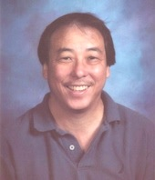

Students are expected to be **in their seat** at the tardy bell.

**Absences:** Students are required to make up work missed due to excused absences within one week. In the event of an excused absence students will need to:

1. Collect work from teachers.
2. Copy notes and planners from a classmate or website.
3. Turn in assignments that were due the date of absence(s) immediately upon return.
4. Meet with teachers to arrange a time to make up class work that you need help with.

**Hall Passes:**  Students are allowed 2 passes per class, per term. The **5-minute** passing time between each bell is a sufficient amount of time to attend to personal business.

Student work should reflect learning and mastery of the individual. Therefore all work should be unique and completed by the individual. When working in groups all students are expected to contribute equally and turn in their own assignments. Students will receive individual grades for group projects based on their contribution. **Copying of ANYTHING other than notes and planners is considered cheating and will result in a zero for that assignment for all parties involved.**

Mrs. Hepworth

# Honesty in Work Completion:

# Tardiness and Attendance:

TEAm WEBSITE

https://sites.google.com/site/butlerteampolarbear/home

Emails

[dale.tominaga@canyonsdistrict.org](mailto:dale.tominaga@canyonsdistrict.org%20)

[terrie.abbott@canyonsdistrict.org](mailto:terrie.abbott@canyonsdistrict.org)

[terry.howell@canyonsdistrict.org](mailto:terry.howell@canyonsdistrict.org%20)

[brianne.hepworth@canyonsdistrict.org](mailto:brianne.hepworth@canyonsdistrict.org)

Phone: (801) 826-6800

**7th Grade TEAM Polar Bears**

Math: Mr. Tominaga

Utah Studies: Ms. Abbott

Science: Mrs. Howell

English: Mrs. Hepworth

Mrs. Howell

Ms. Abbott

**Learning Activities:**

Starters:  Every class begins with a starter (Polar Bear Plunge) to help students begin studying daily topics as soon as the bell rings. Starters will be graded as an assignment.

**If starters are not completed when assigned, students will not be allowed to make them up. In the case of excused absences starter makeup will be at the discretion of the teacher.**

Assignments:  Students are expected to produce **QUALITY work in a timely manner.**

Planners:  Students are required to bring planners to each class daily and use planners to record daily class activities, homework, and important events.

Extra Credit may be awarded based on teacher discretion, but will reflect mastery and participation.

**Re-works/Re-Takes/Revisions:** With the exception of starters, if your first attempt at any learning activity does not accurately portray the level of mastery that you wish to receive; show proof of practice then re-submit the assignment or test.

Reworks without appropriate proof of practice attached will not be graded.

STUDENTS WILL NOT BE ALLOWED TO RETAKE DISTRICT OR STATE MANDATED ASSESSMENTS.

**Make up/Late Work:** Except under special circumstances, **No make up or late work will be accepted after late work deadlines.**

* 09/20/13
* 10/25/13
* 12/20/13
* 01/31/14
* 02/21/14
* 04/11/14
* 05/30/14

Your team teachers will strive to build a culture of responsibility and accountability with adherence to Butler’s GREAT expectations.

**Grading Procedures & Grading Scale:** Grades will be based on student performance during learning activities and will show mastery of the content according to the BRUIN grading scale.

# General Expectations:

Mr. Tominaga

It’s always a GREAT day to be a Bruin!